Opportunity for two Asian Restaurants in Rome, Italy

Mauro Mucci

11th May 2021

# Introduction / Business Problem

## Background

Rome is a multinational European capital and it is one of the most visited cities in the world thanks to its priceless historical value.

Almost 3 million people live in the city and tourism is always very active at any time of the year.

Thus, investing money in a restaurant could provide a very good opportunity for the investors.

### Business Problem

Our client is looking into two different options:

* A luxury and high-level Japanese Restaurant
* An economic “all you can eat” Chinese Restaurant

Depending on the study’s results the client might invest in both restaurants.

Our target is to define two possible areas in Rome where opening the two restaurants could result in the most remunerate business possible.

# Data

## introduction

In order to answer the client’s request, the following data have been analized:

* Municipi_Roma_15_wgs84_1.shp (shapefile)
* ZoneUrbanistiche.shp (shapefile)
* Municipi_di_Roma (Wikipedia Page)
* Zone Urbanistiche di Roma (Wikipedia Page)
* Benessere_economico_DATI2018.xlsx
* Foursquare API

## Data Description

The “***Municipi_Roma_15_wgs84_1.shp***” is a shapefile that contains the coordinates of the polygons for each Municipio of the city of Rome. A Municipio is a subdivision of the city’s territory that is done for administration purpose. It allows us to group important data and characterize each area in order to find the most suitable for the restaurant.

Here is the plotting of the shapefile:

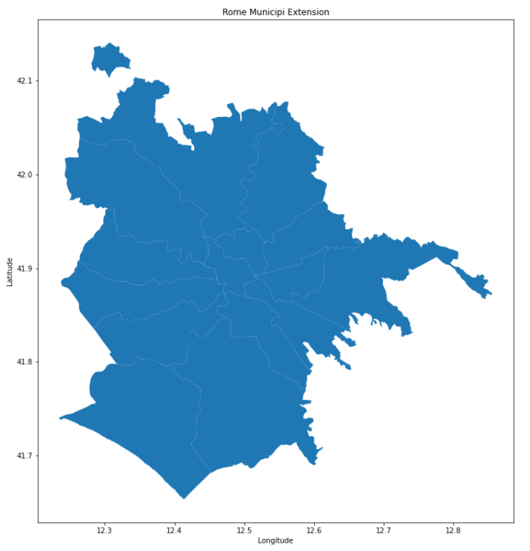

The “***ZoneUrbanistiche.shp”*** is a shapefile that contains the coordinates of the polygons for each Zona Urbana of the city of Rome. A Zona Urbana is a subdivision of the Municipio territory that is done for administration and statistical purpose. Once again, it allows us to group important data and characterize each area in order to find the most suitable for the restaurant.

Here is the plotting of the shapefile:

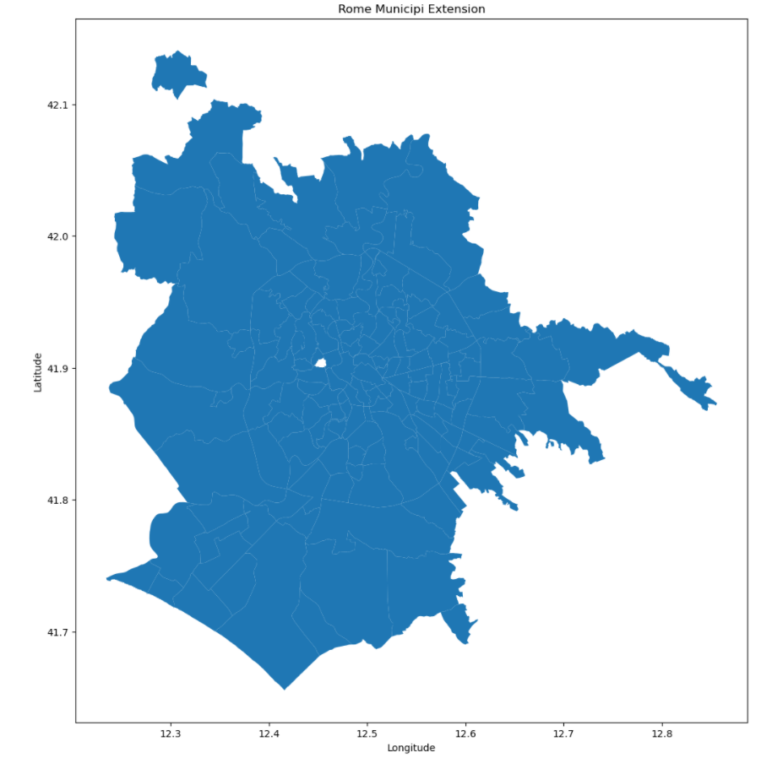

I will scrape the “***Municipi_di_Roma***” [wikipedia page](https://it.wikipedia.org/wiki/Municipi_di_Roma) in order to get important demographical data for each Municipio. The data are from 31st December 2018 and they describe the following: Population, Density and Area dimension.

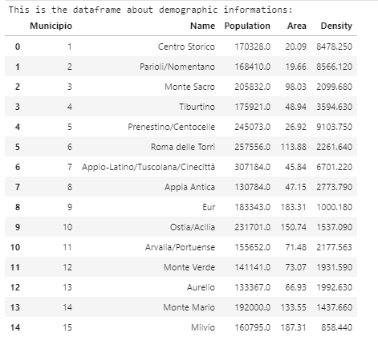

I had to use the “***Zone Urbanistiche di Roma***” [wikipedia page](https://it.wikipedia.org/wiki/Zone_urbanistiche_di_Roma) in order to associate each Zona Urbanistica with its correspondent Municipio, since this information was omitted from the shape file.

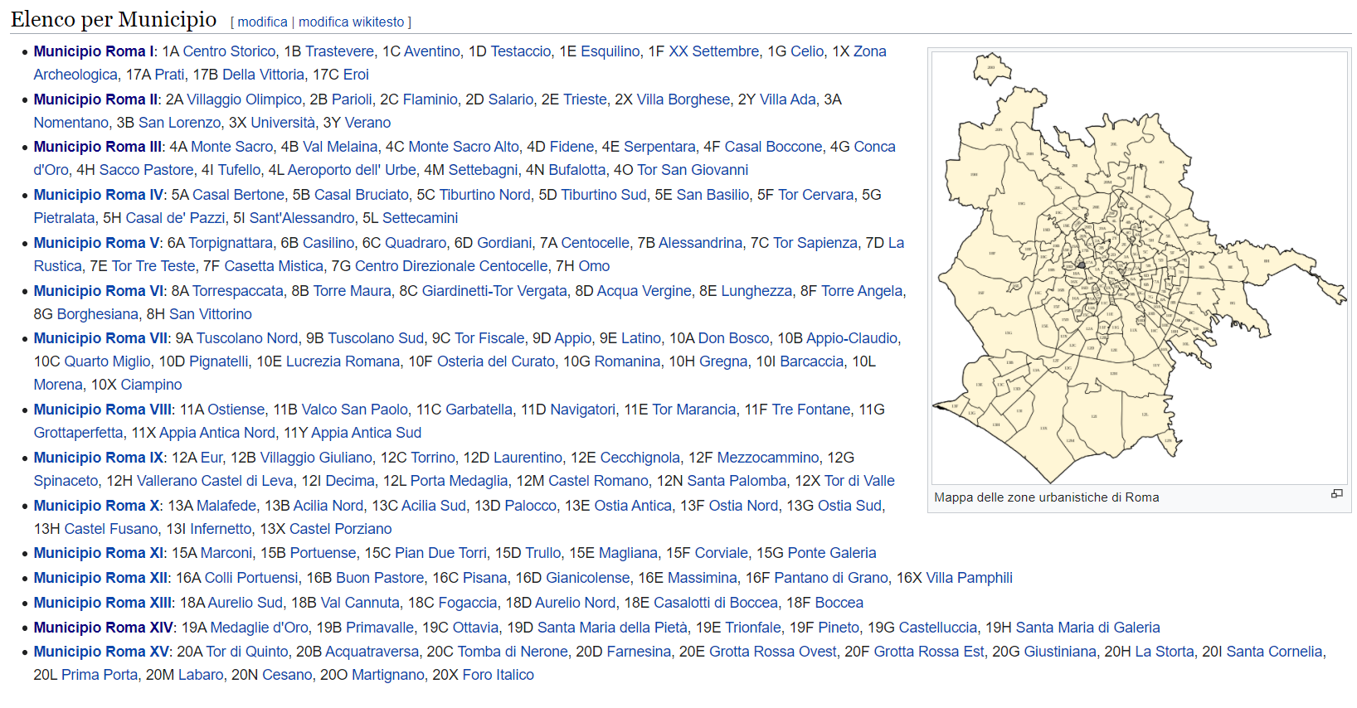

The “***Benessere_economico_DATI2018.xlsx***” excel file contains information about the average yearly salary of the population for each of the Municipio. The data is from the 31st December 2018. This file can be found in the following webpage: <https://www.comune.roma.it/web/it/roma-statistica-benessere-economico1.page>

Here is a screen dump of the excel table:

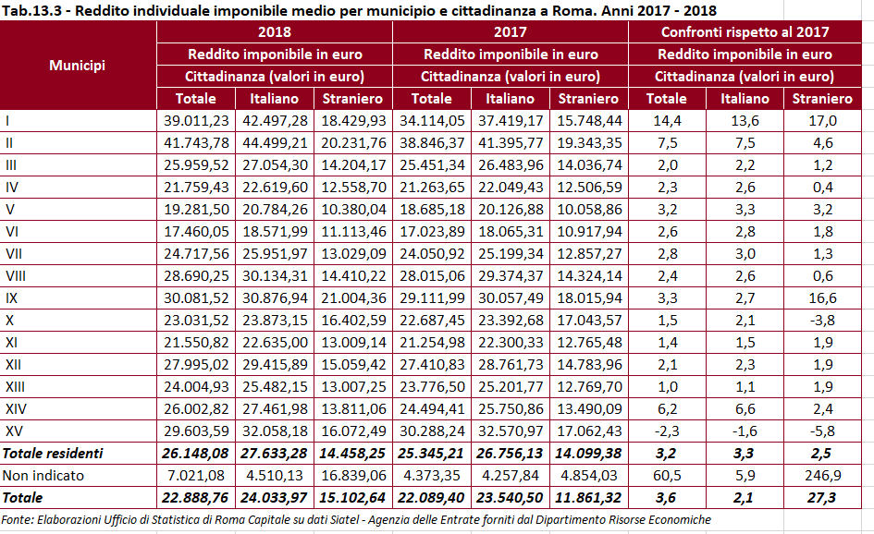

Foursquare API is a very useful service that can provide any sort of information about venues of a particular location. For our project I had to obtain a Restaurants’ dataset that contains the following information: Restaurant Name, Position (latitude and longitude), CAP, Category/Type.

Also, I retrieved data about the venues in the areas of interest.

This is an example of the information retrieved by a Foursquare API request:

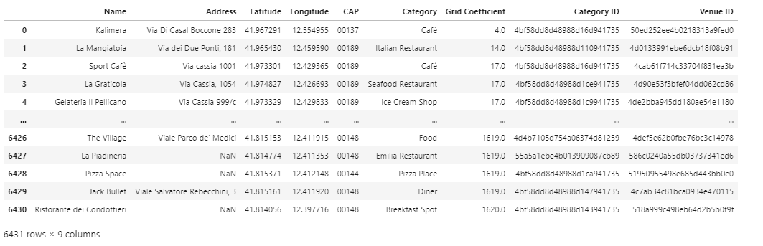

# Methodology

## Introduction

Rome is a huge city and finding a suitable spot for a restaurant is not an easy task without the right methodology.

The first main objective is to delimitate a few areas of interest and then to focus on them.

A luxury Japanese Restaurant needs to be in a wealthy and densely populated area. The area should also come alive in the evenings, so it should already have a good number of restaurants, pubs, clubs and also should have theatres, museums, art galleries and all the kind of venues that are preferred by wealthy people.

An economic ‘all you can eat’ Chinese Restaurant needs to be in a densely populated area that has an average income per capita that can be collocated at the low to medium scale. Ideally, it should be an area that isn’t purely residential.

## Selection of the right Municipio

Through different datasets I created the following data frame:

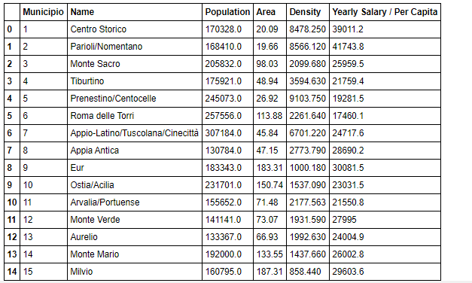

It contains the main demographic indicators to select the right Municipi. The following Choropleth maps show the distribution of the population density and their average income in the whole territory of Rome.

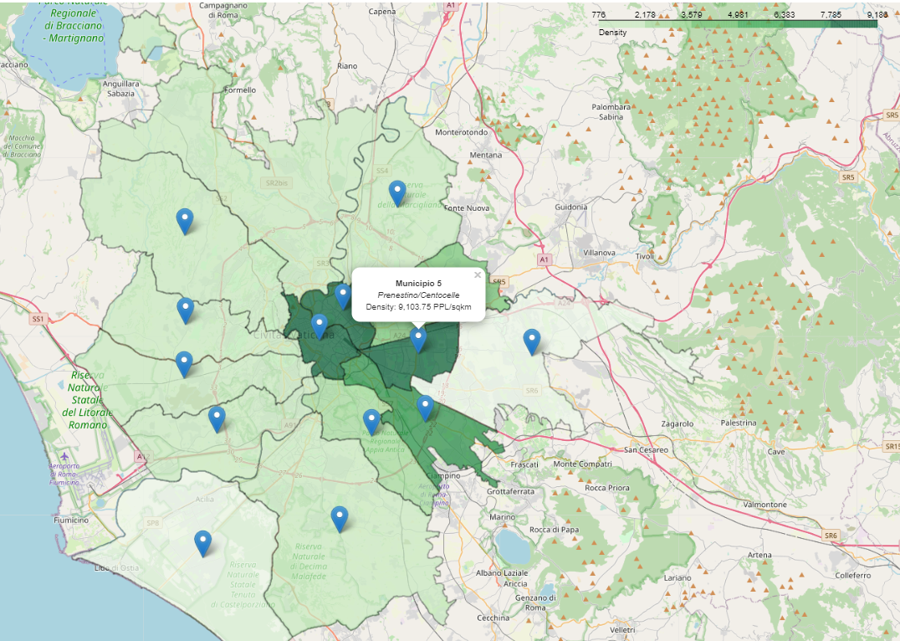

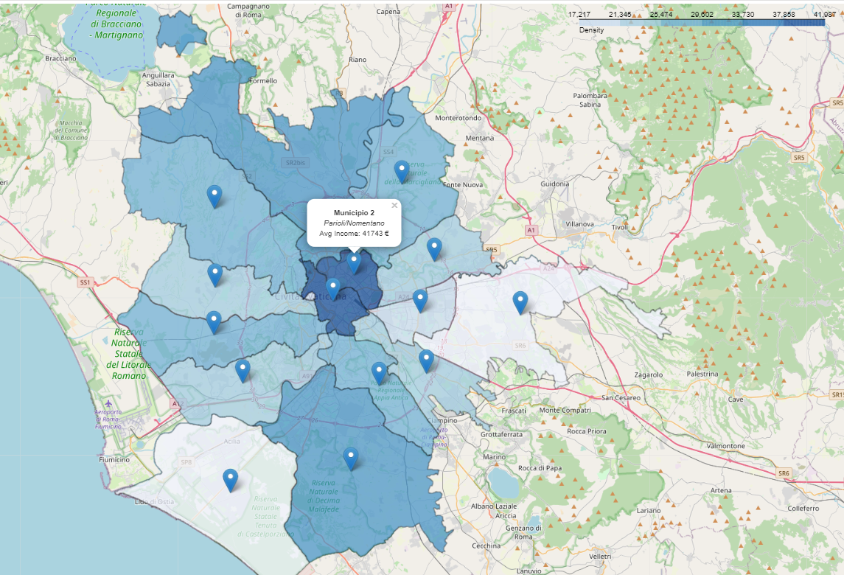

Furthemore, the below graph highlights how Appio-Latino/Tuscolana/CInecittà, Prenestino/Centocelle, Centro Storico and Parioli/Nomentano have the highest density/population ratio.

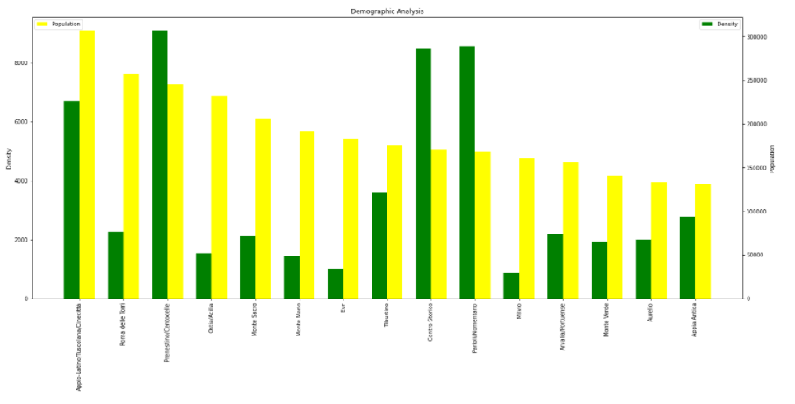

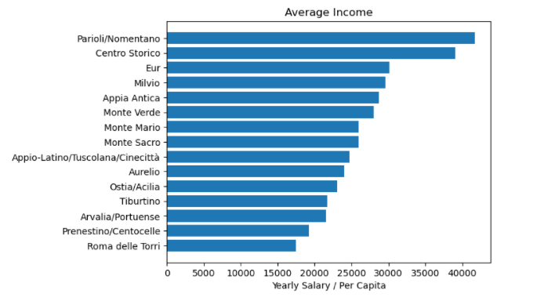

From these data I selected 2 different areas for the Japanese Restaurant:

* Municipio 2 – Parioli/Nomentano with an average income of 41473 € and a population density of 8566 ppl/km2
* Municipio 1 – Centro Storico with an average income of 39011 € and a population density of 8478 ppl/km2

And 2 different areas for the Chinese Restaurant:

* Municipio 5 – Prenestino/Centocelle with an average income of 19281 € and a population density of 9104 ppl/km2
* Municipio 7 – Appio-Latino/Tuscolana/Cinecittà with an average income of 24717 € and a population density of 6701 ppl/km2

## Restaurants in Rome

Since Foursquare API has a limitation of 50 items per each call, I have set a grid of points that cover the whole territory of Rome as shown below:

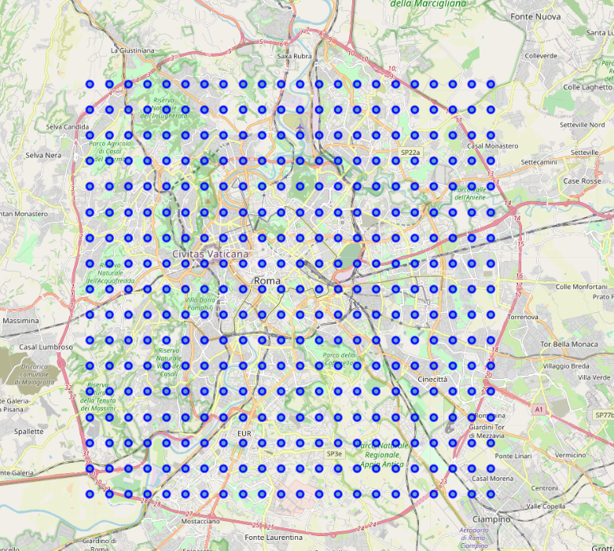

This returns a database of 6431 restaurants. The following graph shows how many restaurants there are for each Municipio. We can see that the selected areas are in the top places as well as for number of Restaurants / km2.

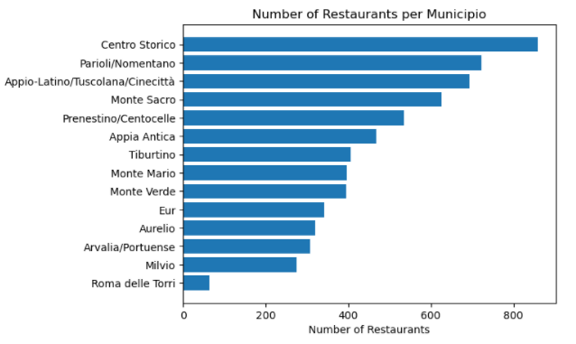

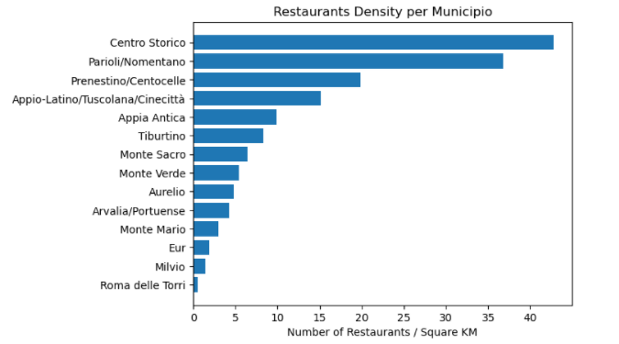

After that I narrowed the search by including only Japanese and Chinese Restaurants. As expected, Japanese Restaurants are already very common in the two wealthiest areas since they are generally expensive.

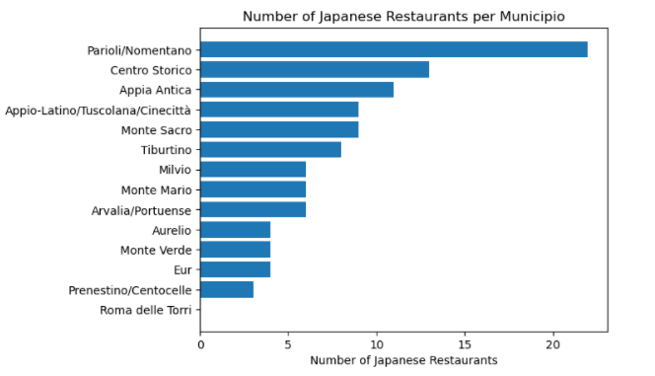

Also, there are already several Chinese Restaurants in both Appio-Latino/Tuscolana/Cinecittà and Prensestino/Centocelle. This confirms that both areas are a good choice for a new ‘All you can eat’ Chinese Restaurant.

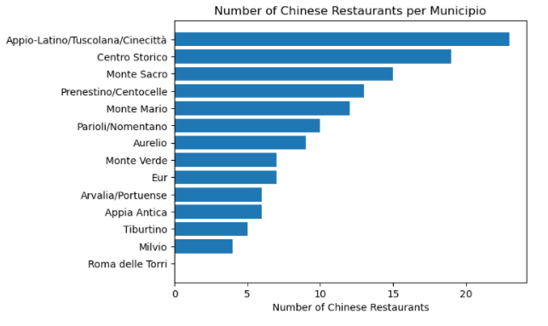

## Selection of the Zona Urbana

I decided to look at each Zona Urbana within the selected areas with the aim of comparing the population density and the number of Japanese/Chinese Restaurants. This was done by using the Zona Urbana shapefile and the Restaurant dataframe.

The aim is to look for high population density with a relatively low number of Japanese/Chinese Restaurant.

This allows me to narrow the attention to the following Zone Urbane for the Japanese Restaurant:

* Eroi
* Testaccio
* Flaminio
* San Lorenzo

As well as these Zone Urbane for the Chinese Restaurant:

* Gordiani
* Appio
* Latino

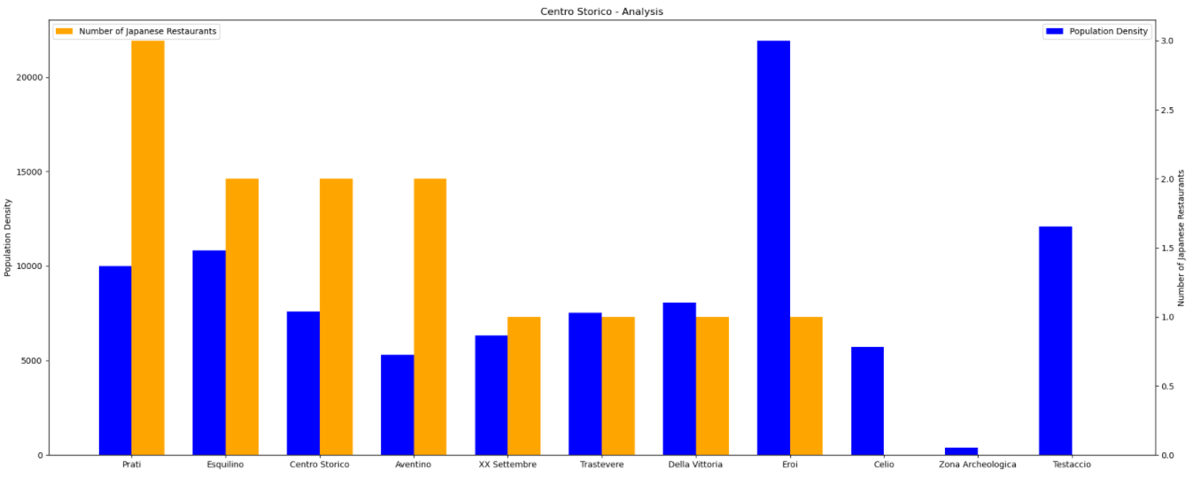

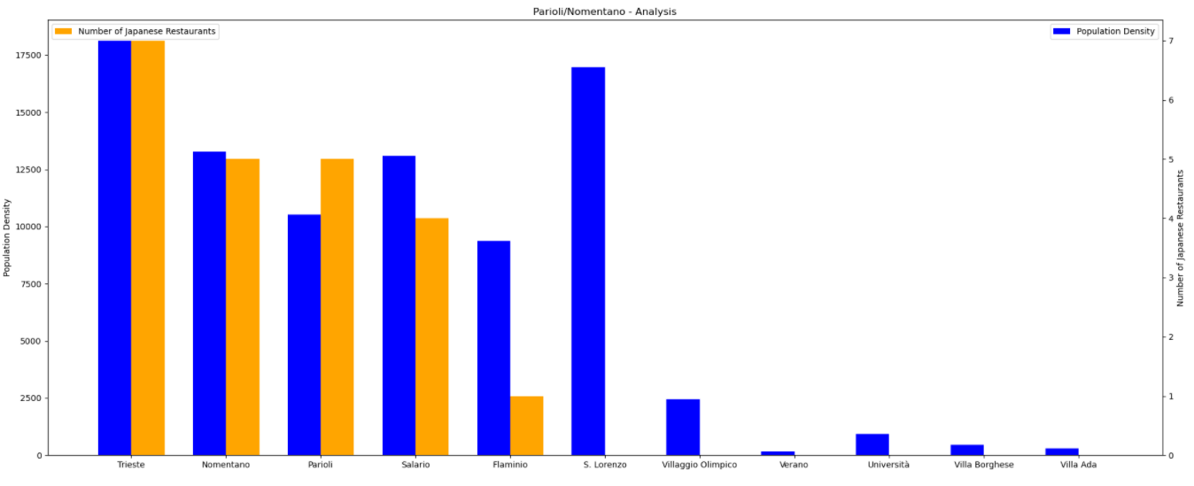

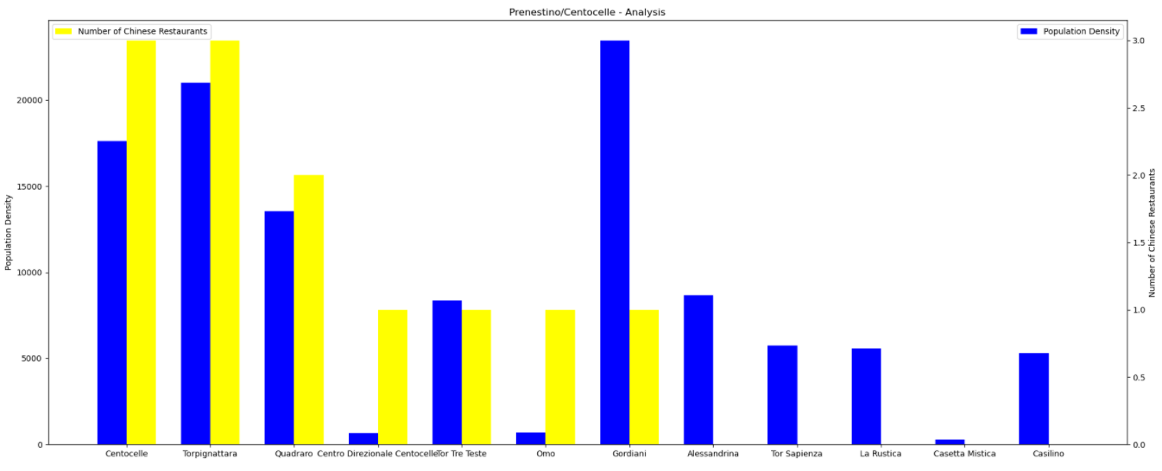

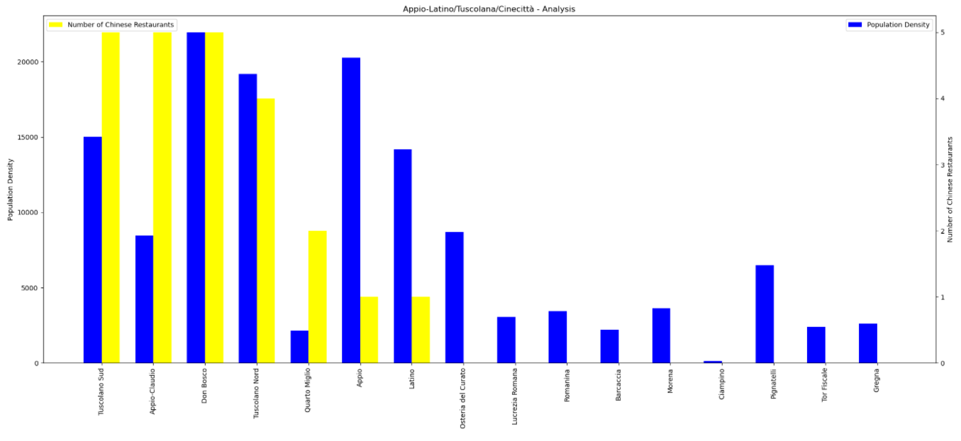

## K-Neighbourhood Cluster

It’s very important to analyse the characteristic of each area in order to see which is more active and alive in the evening time and which one is more residential like.

To do this I used the Foursquare API to retrieve venues of the following categories:

* Art & Entertainment
* College&University
* Night life Spot
* Professional & other Places
* Travel and Transport

Since the k-Neighbourhood Algorithm works with values I converted each Venues category into a binary value (0=not present, 1=present). Then I grouped the data by Zona Urbana and calculated the mean of the occurrences of each category for each Zona Urbana.

The dataframe that was used to fit the Machine Learning Algorithm looks like this:

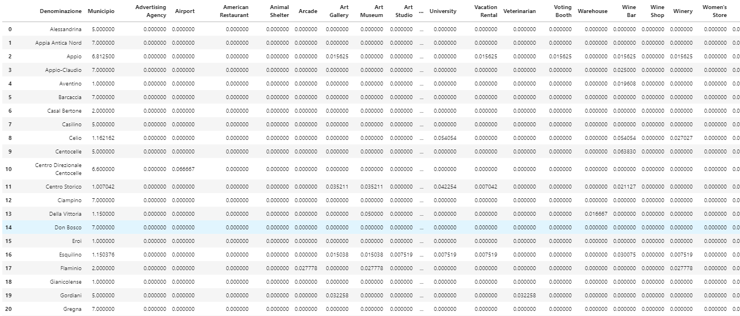

The number of K was set to 4 since we are analysing 4 different areas. Amazingly the final result is very consistent with the original division of the areas and each cluster contains mainly Zone Urbane from the same Municipio.

So, basically:

* Cluster 0 is Parioli/Nomentano,
* Cluster 1 is Appio-Latino/Tuscolana/Cinecittà
* Cluster 2 is Prenestino/Centocelle
* Cluster 3 is Centro Storico

I retrieved the 20 most common venues for each Cluster in order to do some comparison between them.

The last step is to compare the characteristics of the Zone Urbane that I selected, by comparing the 10 most common venues between them.

## Discussion

The graph below shows the 20 most common venues of Cluster 0 (Parioli/Nomentano) compared with the other 3 clusters.

We Can tell that Cluster 0 (Parioli/Nomentano) is a very wealthy area by the presence of Movie Theatre, Colleges, Embassies, as well as Wine bars, offices and hotels. It is also a well-served area by bus lines since it has double the amount of the other clusters.

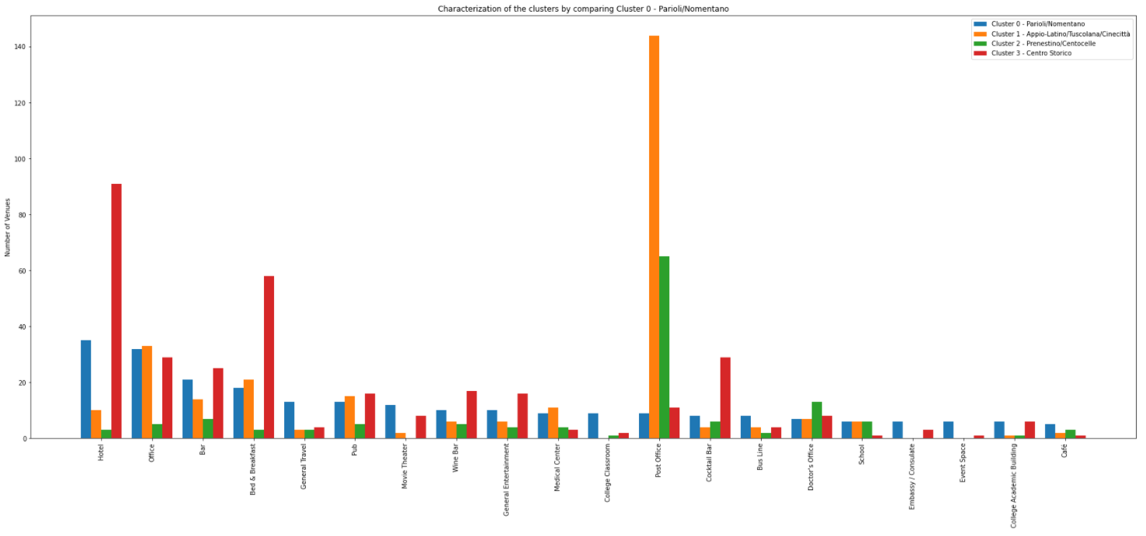

The graph below shows the 20 most common venues of Cluster 3 (Centro/Storico) compared with the other 3 clusters.

Cluster 3 - Centro Storico is definitely the most touristic area having the vast majority of hotels, Monuments, landmarks and Historic sites. It is also quite wealthy with the presence of Art Galleries and Museums, Colleges and Universities. It offers a great social life with cocktail bars, bars, pubs and wine bars.

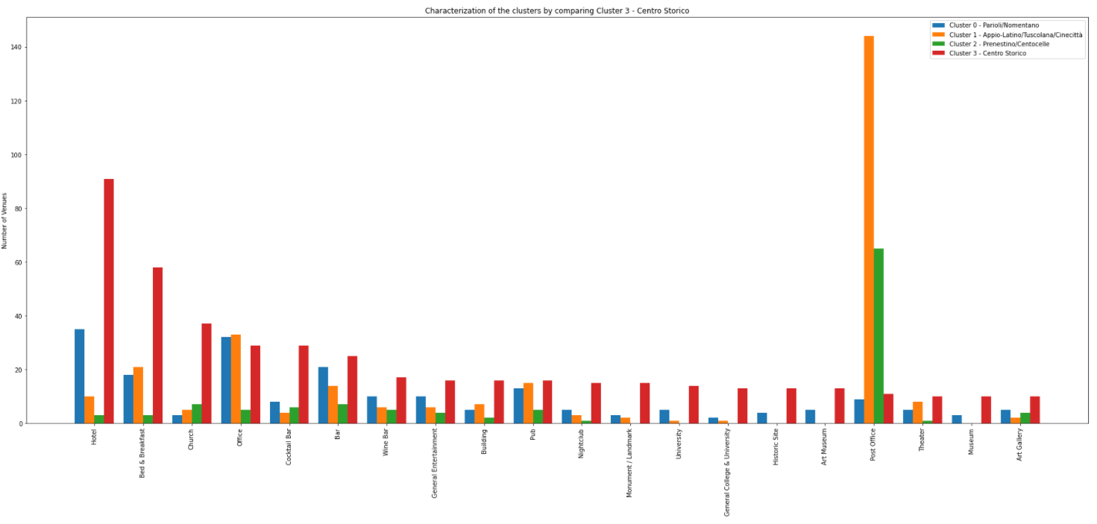

The graph below shows the 20 most common venues of Cluster 2 (Prenestino/Centocelle) compared with the other 3 clusters.

Cluster 2 – Prenestino/Centocelle has generally less venues than the other Clusters. It has the characteristics of a dense populated area that doesn’t offer very much to the inhabitants.

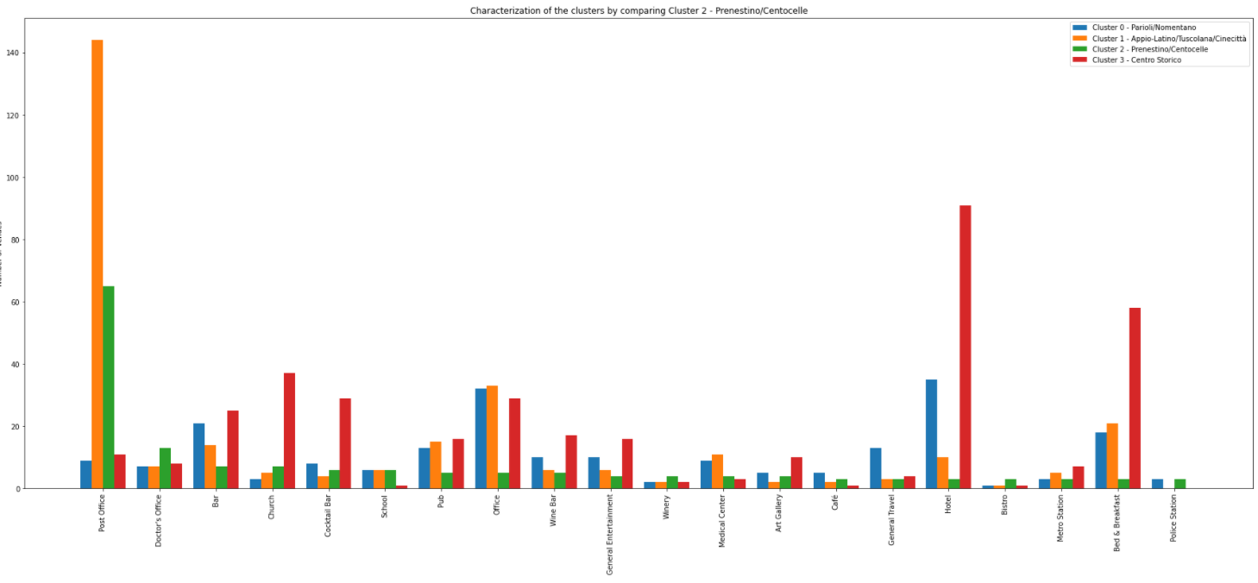

The graph below shows the 20 most common venues of Cluster 1 (Appio-Latino/Tuscolana/Cinecittà) compared with the other 3 clusters.

Cluster 1 – Appio-Latino/Tuscolana/Cinecittà seems to be a popular area with a good night life, given the good number of Pubs, Bars, Theatres and Wine Bars. The number of post offices is incredibly high! But this is not of our interest.

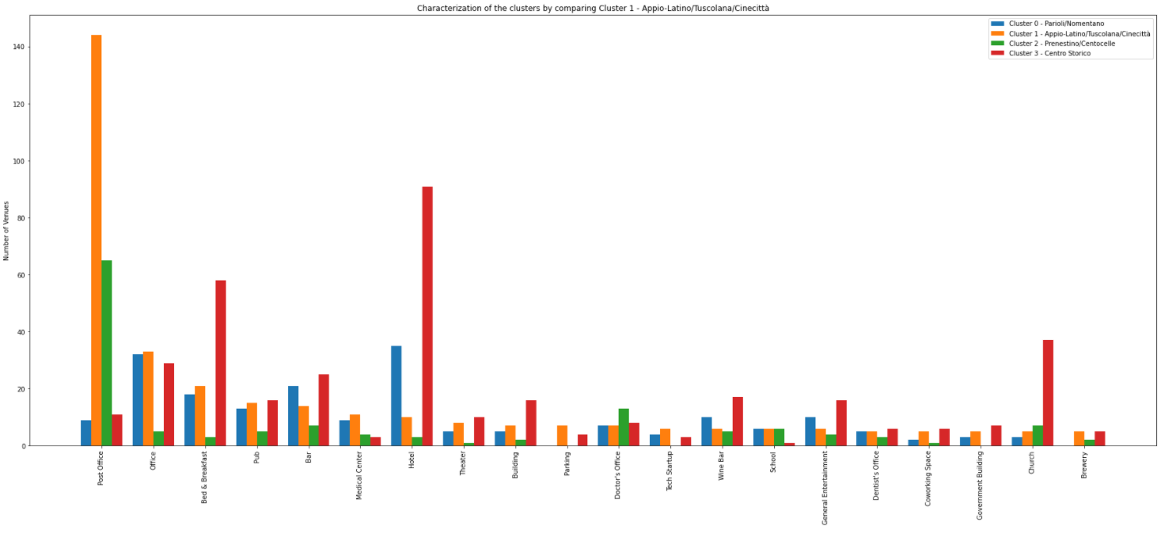

## The luxury Japanese Restaurant

Let’s take a closer look at the venues of the different Zone Urbane.

We’ll start with the Zone Urbane suitable for the Luxury Japanese Restaurant.

From the previous graphs we have seen that Eroi, Testaccio, Flaminio and San Lorenzo have a high population density and only two Japanese Restaurants which are in Eroi and in Flaminio.

Testaccio is the only one that has a substantial number of Theatres, Art galleries and Museum along with a good social life with the presence of nightclubs and cocktail bars. Probably there is a good balance of young and older people.

San Lorenzo has a great number of Rock Club, Bars, Beer Bars, Pubs but it lacks Museums, Theatres and Art galleries. Thus, people in San Lorenzo might be too young to be a good target for a Luxury Japanese Restaurant.

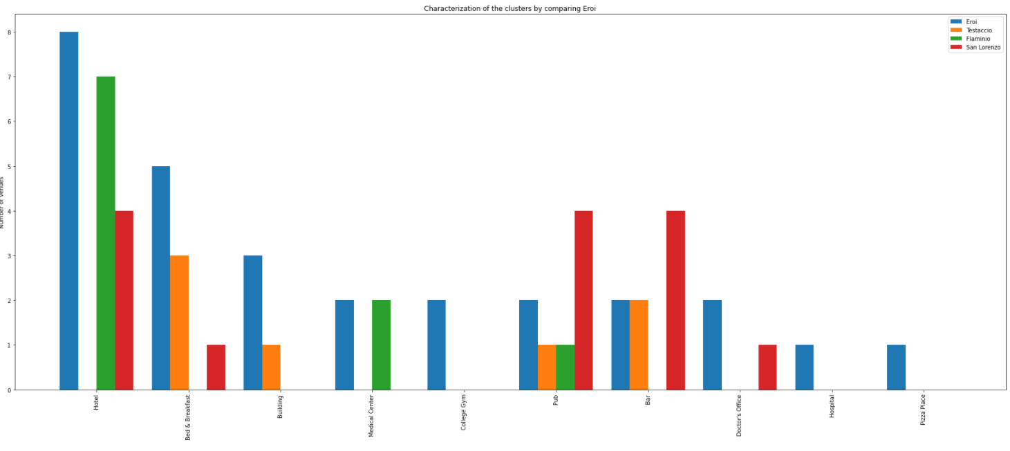

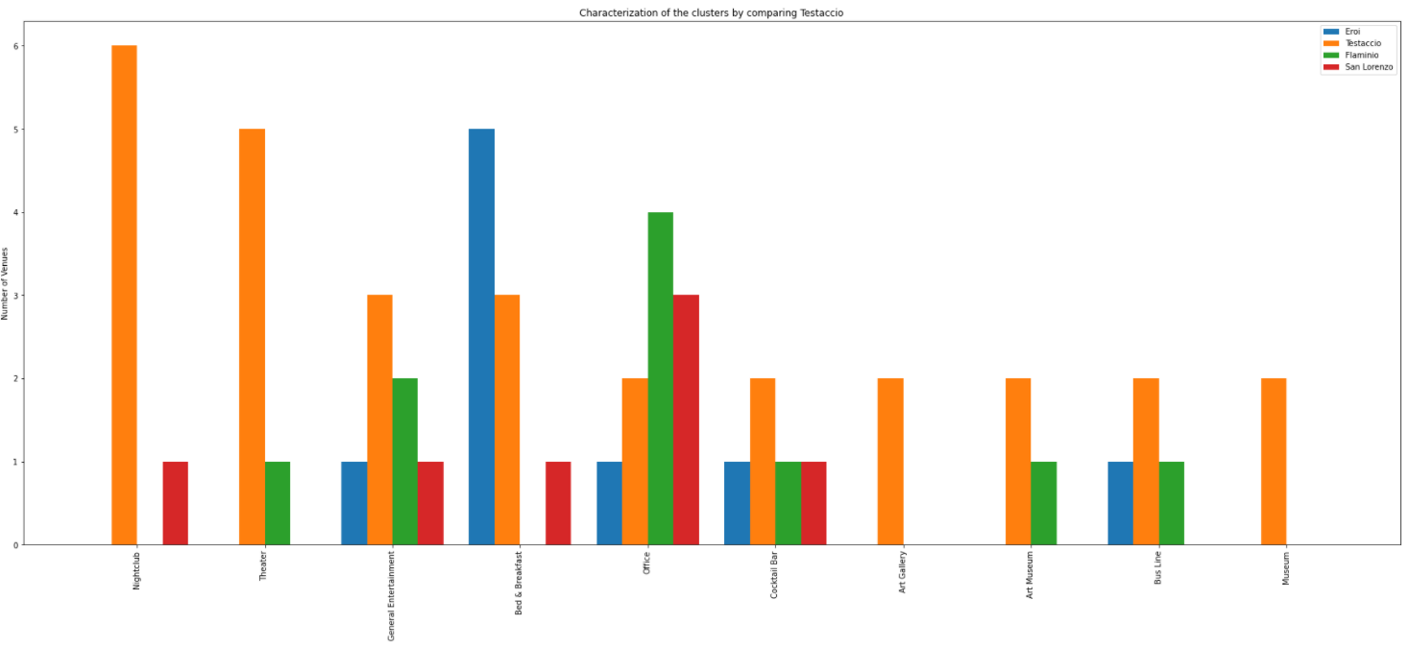

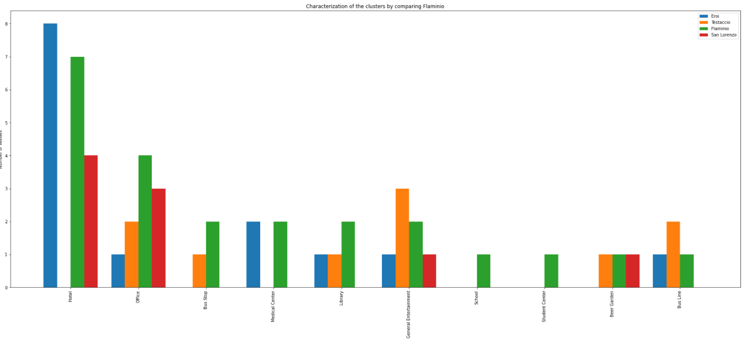

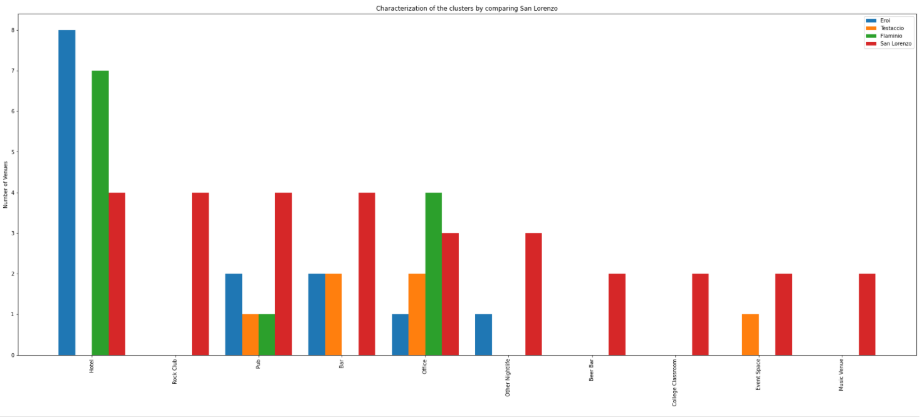

## The ‘All you can eat’ Chinese Restaurant

From the previous graphs we have seen that Gordiani, Appio and Latino have a high population density and one Chinese Restaurant each.

Among the three of them Appio seems to have more social life by the presence of more Pubs, Bars, Hotels and Schools compared to Gordiani and Latino. It is also more densely populated. This makes it a good choice for the Chinese Restaurant.

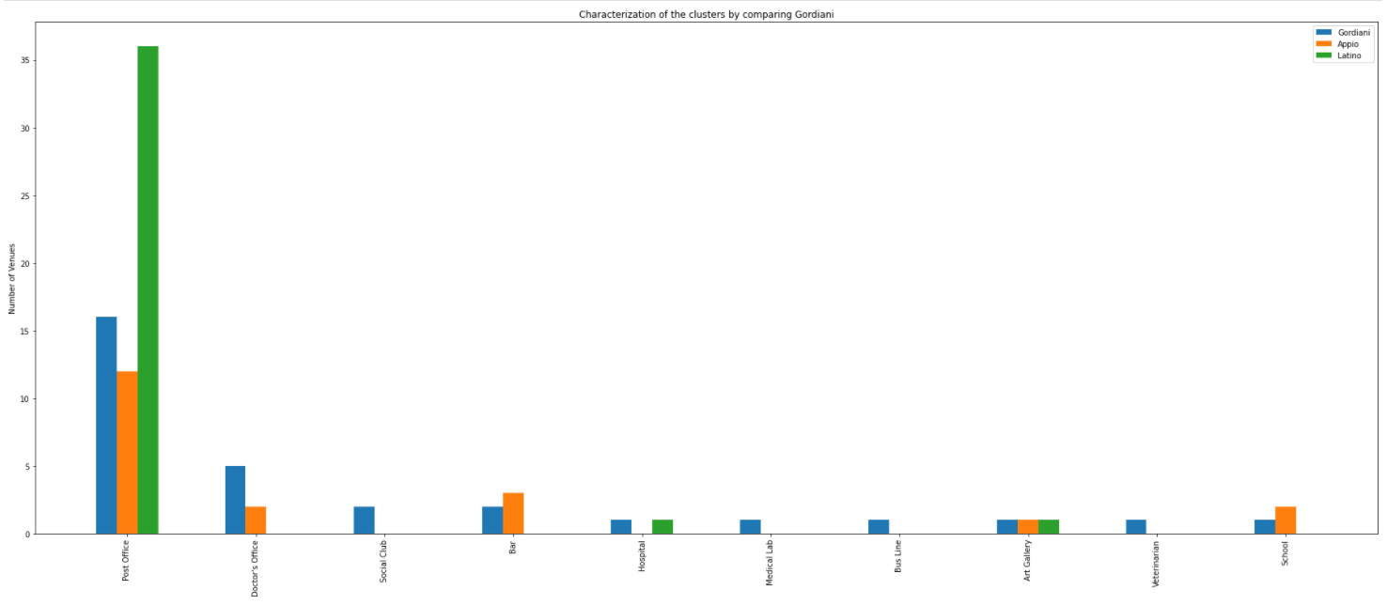

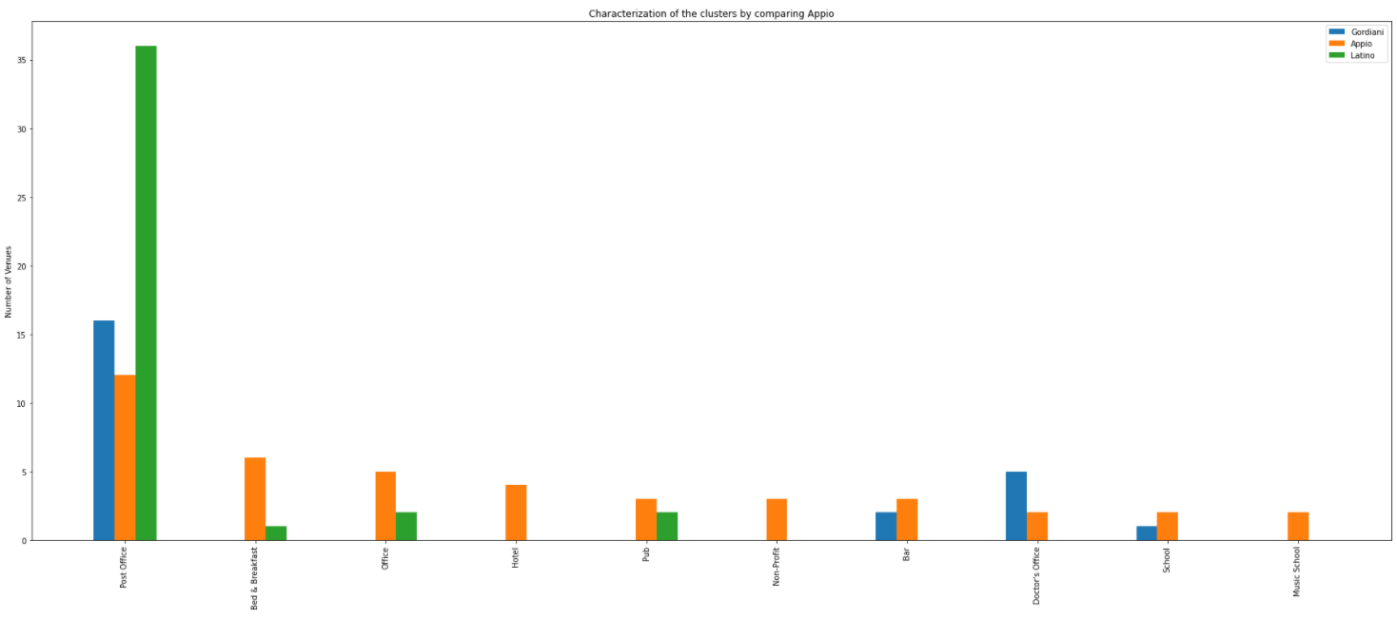

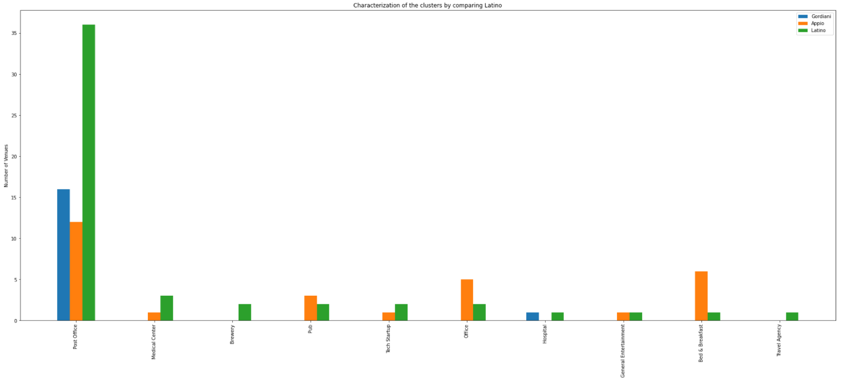

# Conclusion

According to the data analysis and the characterization of the areas in the city of Rome, I conclude that the most suitable area for a luxury Japanese Restaurant would be in the wealthy area of Testaccio, due to the vast presence of social venues and the absence of a Japanese Restaurant.

Whereas, a really good choice for an economic Chinese Restaurant would be in the Appio area. It is one of the highest densely populated zones. Furthermore, it is less wealthy than Testaccio but still has a medium average income.